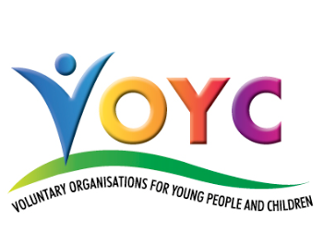

Registered Charity No 1054442

THE 100 CLUB, WEAR BARTON ROAD, COUNTESS WEAR,
EXETER, EX2 7EH
Tel & Fax: 01392 250976
E-mail: admin@voycdevon.org.uk
www.voycdevon.org.uk

CHILD PROTECTION TRAINING – GROUP 2 AWARENESS IN SAFEGUARDING

The Devon Children & Families Partnership (formerly known as Safeguarding Children Board) approved Group 2 training (formerly level 2) is an important part of workforce development for any organisation working with children and young people as it is essential to help protect children and young people in Devon.

Target group: Those who work regularly, or have a period of intense but regular contact with children and young people or with staff who may be in a position to identify concerns and who may be expected to contribute to the assessment of the child’s developmental needs or the adult’s parenting capacity.

Overview: ‘Awareness in Safeguarding’ is to increase awareness and confidence building in respect of identification, responding, recording and reporting processes involved in child protection. It will also raise awareness of legislation, attitudes & values and blocks & challenges in safeguarding.

The courses are as follows:

Bideford | 9a Caddsdown Industrial Park (Next door to Devonshire Pine Factory), Clovelly Road, Bideford, EX39 3DX | Thursday 31 May 2018 (10 am – 1 pm).

The learning outcomes are printed on the second page of this letter.

*COURSE FEE

£25 per candidate for VOYC member organisations and £30 per candidate for non-members.

If you are not already a member … If you would like your organisation to become a member, the application process is quick and easy with only one short form to complete and send back with your group’s relevant documents and, more importantly, is absolutely FREE! Here are just a few reasons why you should consider becoming a VOYC member:
- Discounted training
- FREE newsletters and bulletins
- Networking opportunities
- Professional support
- Plus much more …

Just call the office on 01392 250976 for your application form or look online http://www.voyc.org.uk/join-voyc

Please advise any workers you know within the sector that they can access this training through the VOYC Devon. Please complete the attached booking form in order to secure your place/s. I should point out that numbers are limited and, due to the popularity of these training days, is on a strictly first come first served basis. Your place/s are secured upon receipt of booking form and monies.

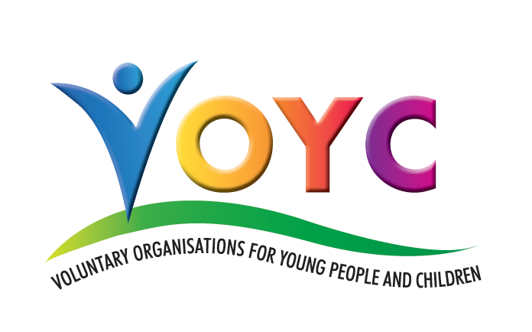
Devon Children & Families Partnership
recognised Group 2
Child Protection Training

Child abuse and neglect are realities in our communities. Awareness of child protection is essential for all practitioners working with children and young people.

This course looks at:-

- Knowing what is child abuse and the signs and indicators of abuse and neglect.

- Knowing who to speak to if you have identified a safeguarding/child protection concern, relevant to the role and responsibility.

- Understanding your own safeguarding roles and responsibilities, and those of other agencies.

- Being able to demonstrate and understand the risks associated with the internet and online social networking.

- Using the Threshold Tool to identify needs and vulnerabilities.

Aims of Training:
The course aims to enable you to recognise your role and responsibilities in safeguarding and protecting children and know how to raise concerns.

Objectives:

 Recognise the possible signs and symptoms of child abuse.
Recognise your role and responsibilities and that of other agencies.
Discuss the challenges faced in dealing with child abuse.
Access further support and training.

CHILD PROTECTION TRAINING – BOOKING FORM
(A Lesson Programme will be forwarded one week prior to the event
together with directions).

Thursday 31 May 2018 – Bideford – 9a Caddsdown Industrial Park

(Next door to Devonshire Pine Factory), Clovelly Road, Bideford, EX39 3DX
(10 am - 1 pm) at £25/candidate for member orgs and £30/candidate
for non-member orgs.

*FEES ARE DETAILED ABOVE - If you are unsure whether or not your organisation is a member of VOYC, please phone the office on 01392 250976.

 | Names of people attending  (PLEASE SPELL CORRECTLY) | *Fee  (see above) |  | Names of people attending  (PLEASE SPELL CORRECTLY) | *Fee  (see above)
1 |  |  | 4
2 |  |  | 5
3 |  |  | 6
Please state if any candidates require disabled access arrangements:
___________________________________________________________________

ORGANISATION NAME ……………………………………...…………………………….

NAME OF PERSON COMPLETING FORM: ……………………………….…..…………

ADDRESS …....…………………………………E-MAIL:.…………………………………

POSITION IN ORGANISATION…...………………………………TEL NO........………...

HOW DID YOU HEAR ABOUT VOYC DEVON? …………………………………………

Please return this booking form, together with cheque made payable to
“VOYC - Devon” (which is non-refundable) to:
VOYC (Devon), The 100 Club, Wear Barton Road, Countess Wear, Exeter, EX2 7EH

Should you prefer to pay on-line, our bank details are:
Name of Bank: CAF Bank Ltd Sort Code: 40-52-40 Account Number: 00018626
Name of Account: VOYC – Devon
Please put your organisation name as a reference followed by ‘CPT’ and email the office to inform them that the payment has been made (juliet@voycdevon.org.uk)

